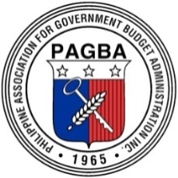

Philippine Association for Government Budget Administration (PAGBA) Inc.
Units N & O, 9th Floor , Lansbergh Place Condominium,
170 Tomas Morato Avenue, Corner Scout Castor St., Quezon City
Website : www.pagba.com Email: admin@pagba.com
September 12, 2026

President
Zenaida M. Bolor-Chang, CPA
Former Assistant Commissioner
Bureau of Internal Revenue

Executive Vice-President
Luz M. Cantor, CPA
Former Undersecretary
Department of Budget & Management

Vice-President for Internal Affairs
Angelo Fidelino B. Villanueva, CPA
Deputy Secretary General
House of Representatives

Vice-President for External Affairs
Atty. Lynn Danao-Moreno, JD
Former Assistant Executive Secretary
Office of the President

Secretary
Ursula Editha O. San Pedro, CPA
JBC Chief of Office (Director IV)
Supreme Court of the Philippines

Assistant Secretary
Gregorio C. Rulloda, CPA
Vice President-Internal Audit Group
Philippine Health Insurance Corporation

Treasurer
Cecilia C. Almajose , CPA
Former Provincial Accountant
Rizal Provincial Government

Assistant Treasurer
Ma. Cecilia M. Narido, CPA
Director IV
Department of Budget and Management

Auditor
Beverly L. Letada, CPA
Chief Administrative Officer
Commission on Audit

Business Managers
Adelaida C. Navarro-Banaria, CPA
Former Finance Director
Securities & Exchange Commission

Imelda R. Dela Cruz
Director IV- Financial Management Service
Department of Environment and Natural Resources

Public Relations Officer
Claridith L. Udani-Paciente, CPA
Corporate Finance Services Chief
Philippine Ports Authority

Trustees
Julius B. Japa
Director IV
Office of the President

Wilma T. Unana
Chief Administrative Officer
Professional Regulation Commission

Aileen M. Tillah
Administrative Officer V
Department of Public Works and Highways

(FULL NAME-BOLD)
(Designation)
(Agency)
(Address)

ATTENTION: Budget/Finance Officers, Accountants, Procurement/Administrative/Legal/ Personnel Officers, Cashiers/Treasurers, Comptrollers, Planning/Development Officers, Internal Auditors, Fiscal/School Administrators, Bids and Awards Committee Members

Dear (Recipient) :

Greetings !

The Philippine Association for Government Budget Administration (PAGBA) Inc., offers anew a line-up of topics - all attuned to a single objective: to sustain the provision and facilitation of capacity-building requirements relative to sound public financial management and good governance including worthwhile information on work-life balance.

The 2026 theme, “Navigating Uncertainty: Building Resilience and Strengthening Reform Initiatives in Public Financial Management” connotes a task to financial managers on how to respond to structural reforms attendant to digitalization and a call to civil servants that service responsiveness requires continuing information and professional development.

Hence, we would like to invite you and the concerned officer/s of your agency to attend and participate in the CY 2026 3rd PAGBA Seminar Cum Convention to be held on December 9-12,2026, at the Garden Orchid Hotel, Zamboanga City. We have invited distinguished experts/resource speakers who will discuss the following topics:

- Cash Management and Control: Strengthening Accountability in the Use of Public Funds
- Guidelines on the Procurement of Motor Vehicles
- RA 11995 – Philippine Ecosystem and Natural Capital Accounting System
- Tax Updates
- PRC Rules and Regulatory Compliance: Updating Professionals
- Salient Features of RA 12009, “The New Government Procurement Act”
- Updates on GSIS Policies and Programs
- PhilHealth: Strengthening Primary Care Financing as the First Line of Financial Risk Protection
- Rules on Administrative Discipline and Data Privacy

We encourage you and your officers to be part of this another very exciting learning experience with other PAGBA members. Your active participation, as well as inputs during the seminar-workshop will be highly appreciated.
For this seminar, each participant shall pay a registration fee of PhP11,200.00 per NBC No. 596 dated January 20, 2025, annual dues of PhP300.00 and one-time membership fee of PhP200.00.
For your convenience, online registration and early payment are required. To register online, you may visit our website, www.pagba.com. Check/cash payment should be issued/addressed to the Philippine Association for Government Budget Administration (PAGBA) Inc., or PAGBA Inc. and deposit to the Land Bank of the Philippines Account No. 1692-1000-30 (COA Branch).

Once payment has been deposited, please send, thru email, the scanned deposit slip or LDDAP to admin@pagba.com.

We have posted in our website a list of nearby hotels, inns and condotels for your information and guidance.

Should you have further inquiries, please email the Secretariat at admin@pagba.com or call Ms. Rosalina Cenon at cellphone numbers 0926-6171215 and/or Arlene Estimada at 0927-7725645.
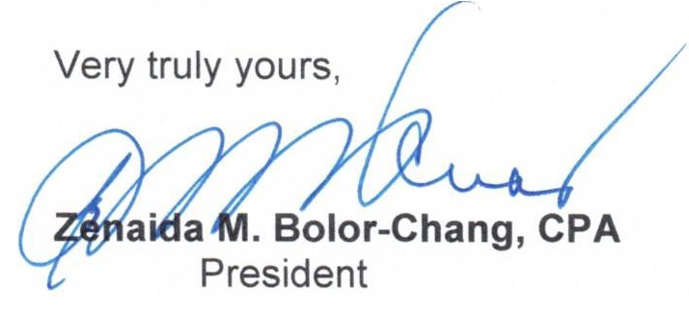

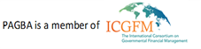
Advisers
Atty. Cyril E. Ramos, CPA
Corazon M. Ordoñez, CPA

